Mini Activity 5: Write a program that asks the user for two numbers and adds them

Test Date | What you expect to happen | What happened | Screenshot | How you fixed it | What type of error did you have? Compile, run time or logic?
9/07/2025 | I should get the two numbers from the user added together | I got an error that says “unterminated string literal” | 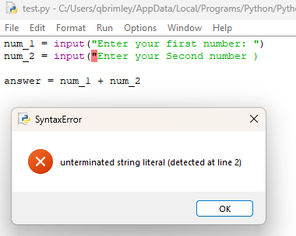 | I added “ to the end of line 2 in my input string | Compile
9/19/2025 | I was expecting the two numbers to be added together | I got the two numbers added together, and it gives to 1 decimal | 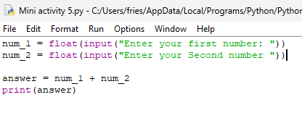 | I added the float feature, and therefore added another “()” | none

